LAB # 6
Deadlock in concurrency:
OBJECTIVE:
Implementing multiple thread blocked resources with help of lock and deadlock conditions.
Lab Task:
Create three threads by implementing thread synchronization block through 3 locks. (Hint: Apply un-sequenced lock to analyze deadlock and solve it through provided solution:
Code:
Deadlock Version (Unsequenced Locks):
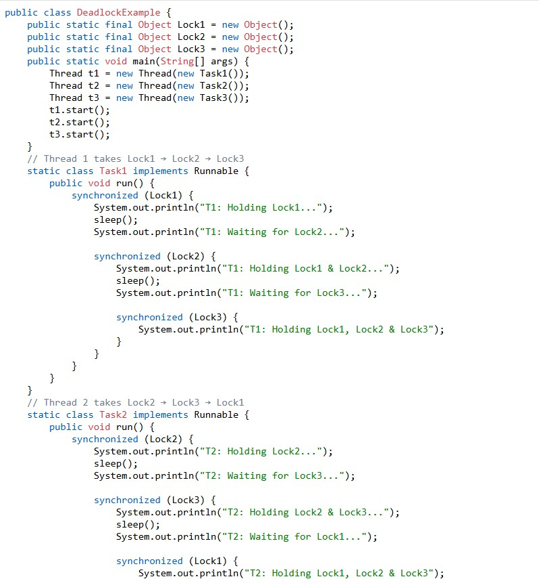
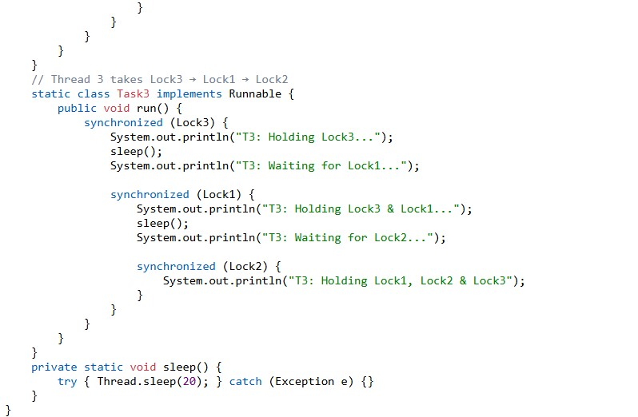
Output:
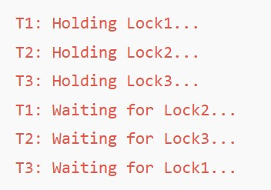

Deadlock Version (Sequenced Locks) Code:
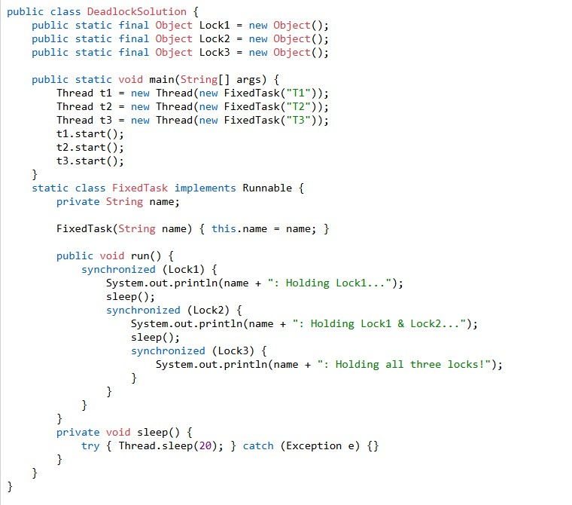
Output:
